

DEPARTMENT OF COMPUTER ENGINEERING

Case Study Report

On

Enhancing a Blogging Application with JavaScript Implementing the Add Entry Feature

By

Aniket Bidgar (21C0026)

Under Supervision of

Prof.S.F.Sayyad

Academic Year: 2023-24(Term-II)

Savitribai Phule Pune University



DEPARTMENT OF COMPUTER ENGINEERING

CERTIFICATE

This is to certify that Aniket Bidgar (21C0026) from Third Year Computer Engineering has successfully completed his work titled" Case Study On Enhancement in created blogging application using JavaScript " AISSMS College of Engineering, Pune in the partial fulfilment of the Bachelor's Degree in Engineering.

Project Guide

Prof. S. F. Sayyad

Head of the Department

S. V. Athawale

Principal

Dr. D. S. Bormane

**Introduction :**

In the digital age, blogging has emerged as a significant platform for sharing ideas, experiences, and knowledge. A robust blogging application is essential for bloggers to engage with their audience effectively. This case study explores the process of enhancing a blogging application using JavaScript, specifically focusing on the implementation of the "Add Entry" feature. This feature allows users to create and add new blog entries, enabling a dynamic and interactive user experience.

**Background :**

The blogging application under review was initially a static platform with a basic interface. It allowed users to view pre-existing blog entries but lacked the capability to create or add new content dynamically. This limitation reduced the application's usefulness and engagement potential. The need to implement an "Add Entry" feature became apparent to make the platform more interactive and user-friendly.

**Objectives**

The primary objectives of this enhancement project were:

1. To enable users to create and add new blog entries dynamically.
2. To maintain a seamless and user-friendly interface during the process.
3. To ensure the application's robustness, scalability, and maintainability.

**Implementation**

1. Designing the User Interface (UI)

The UI design focused on creating a simple and intuitive form for users to add new blog entries. This form included fields for the blog's title and content, along with a submit button. The design prioritized accessibility and ease of use, ensuring users could interact with the application without difficulty.

2. Developing the Add Entry Feature with JavaScript

The core of the enhancement involved JavaScript to handle the "Add Entry" functionality. A JavaScript event listener was used to detect form submissions. When a user submitted a new blog entry, JavaScript code dynamically created a new blog entry element and added it to the list of existing entries. The code also provided functionality to edit or delete entries.

3. Styling and Layout Adjustments

To ensure a polished and consistent look, CSS styling was used to define the appearance of the blog entries and the form. Proper spacing, padding, and borders were applied to create a clean and visually appealing interface. Additionally, the layout was designed to be responsive, allowing users to interact with the application on various devices.

4. Testing and Quality Assurance

Before final deployment, extensive testing was conducted to ensure the new feature worked as expected. This included:

Functional testing to verify the "Add Entry" feature's behaviour..

Usability testing to ensure the user experience was intuitive and smooth.

Compatibility testing across different browsers and devices.

**Outcomes Of Case Study**

Homepage :

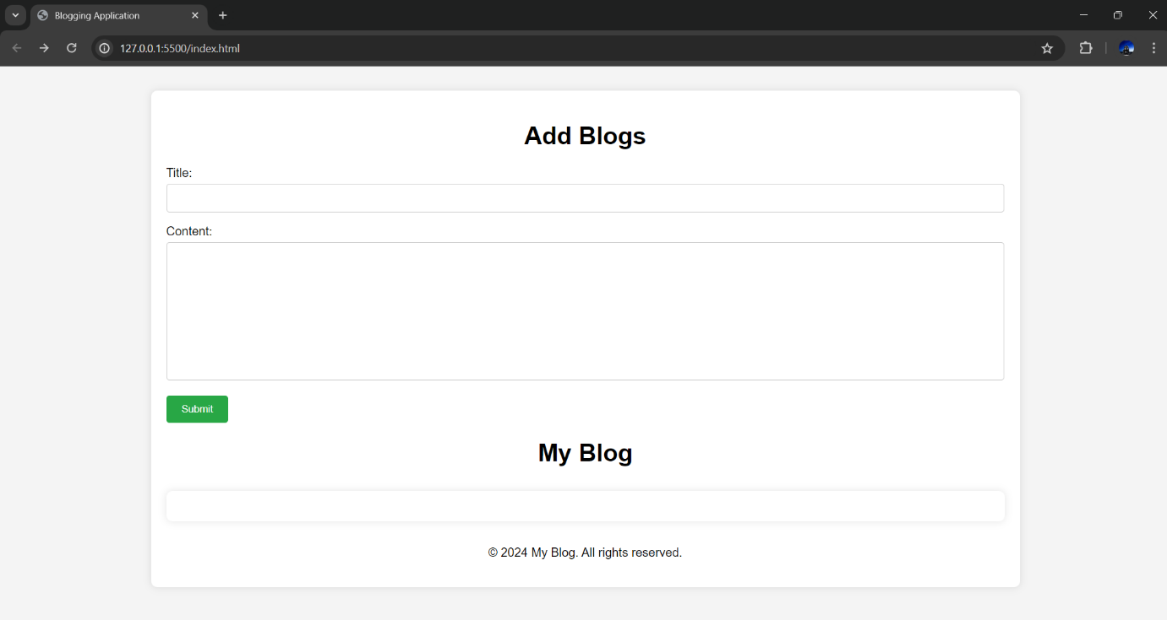

Add Entry Feature :

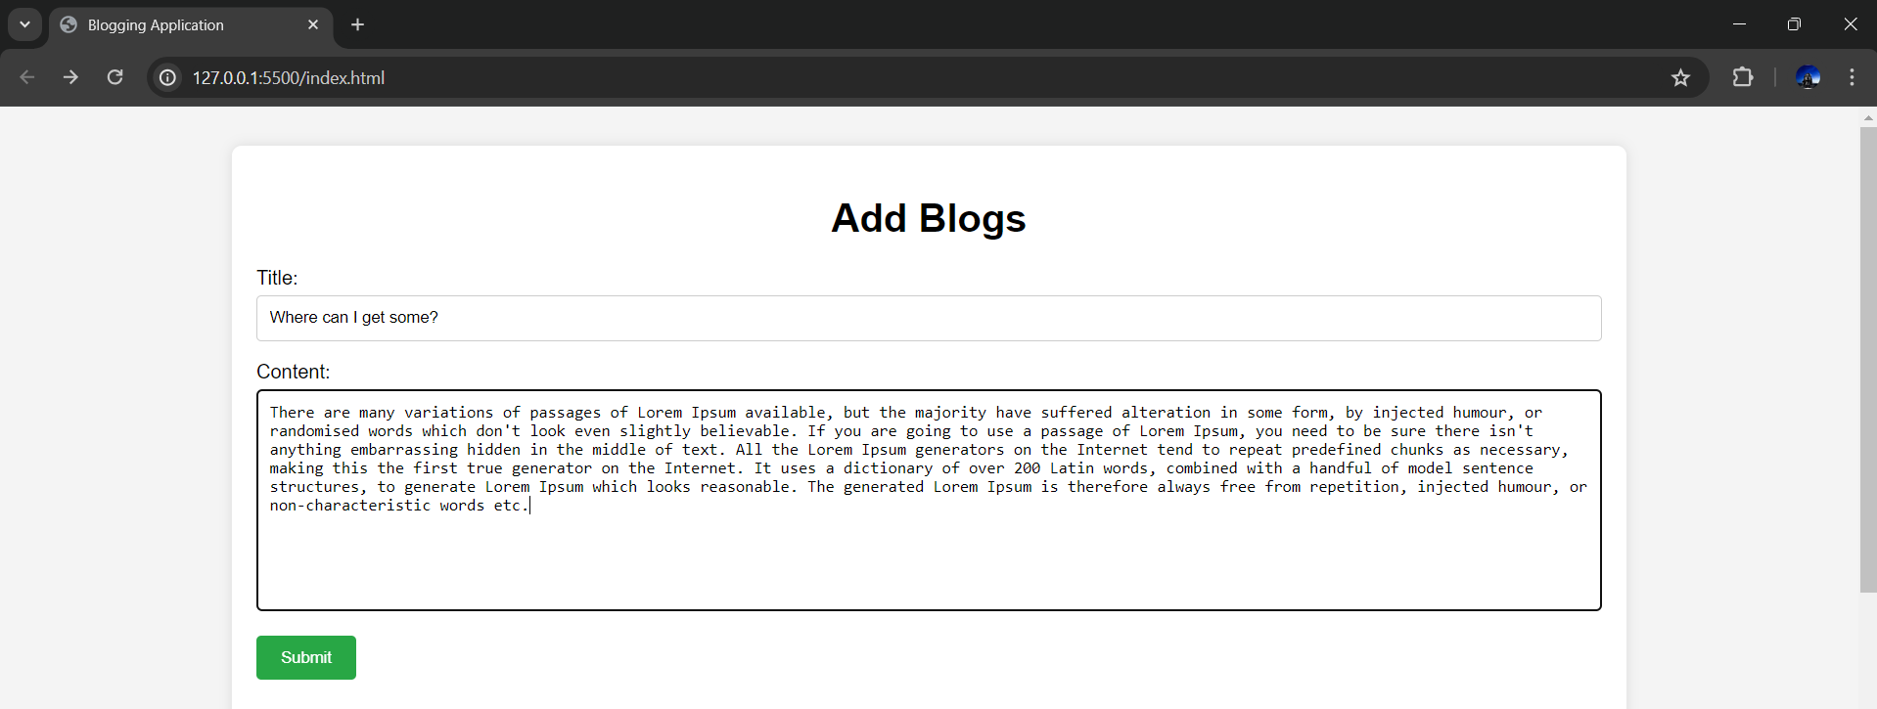

Blogs :

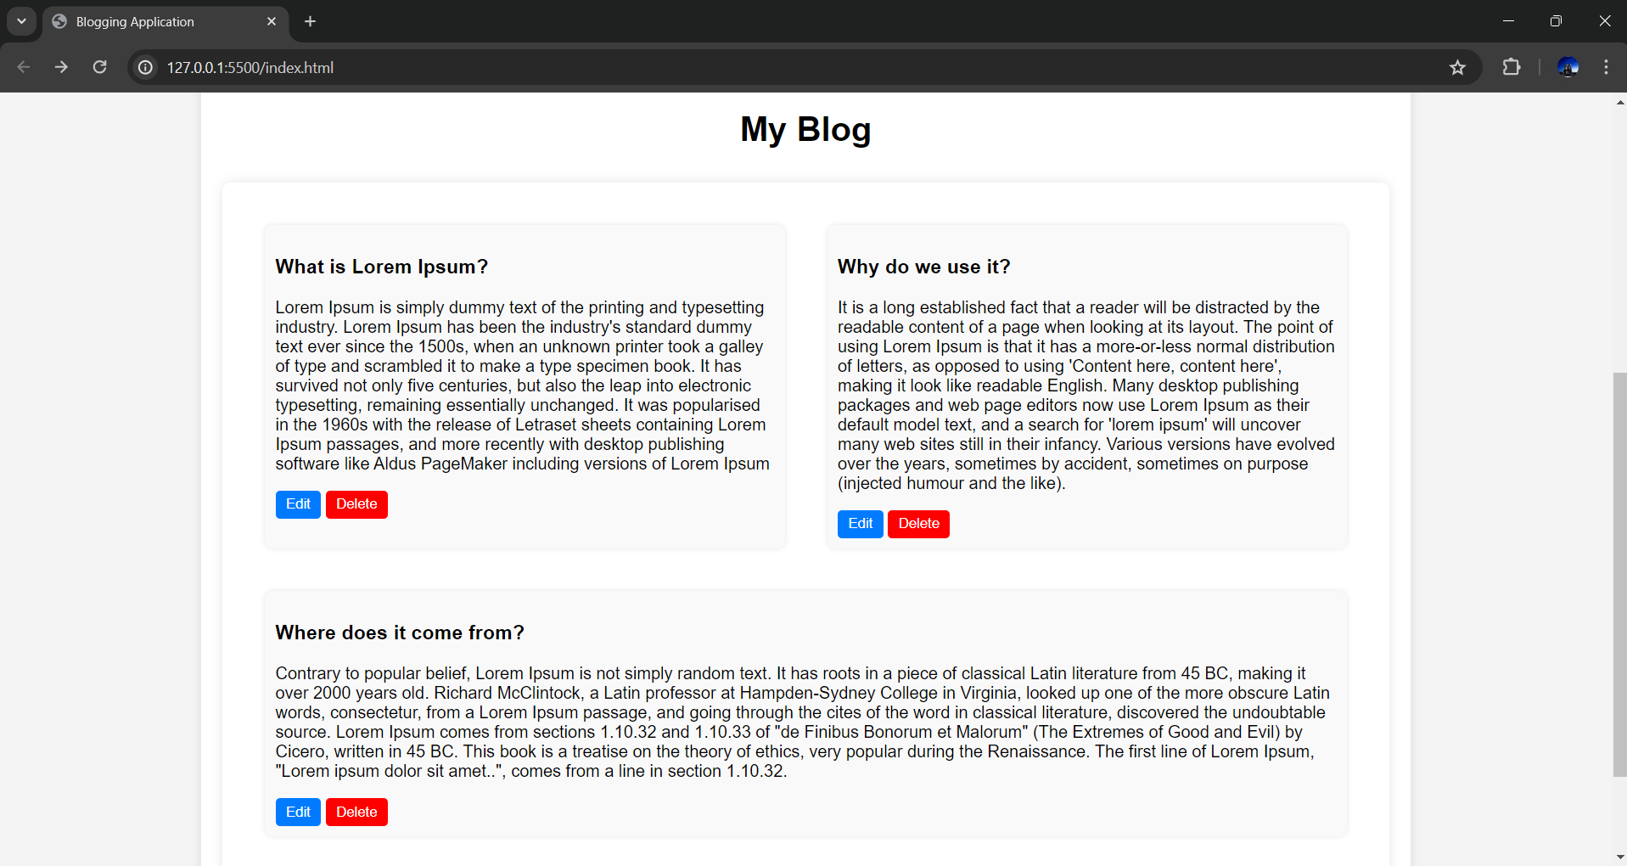

**Results**

The implementation of the "Add Entry" feature significantly enhanced the blogging application. Users could now create and add new blog entries, improving engagement and interaction with the platform. The application's scalability was ensured by using dynamic JavaScript operations and adhering to best coding practices.

**Conclusion**

The enhancement project to add the "Add Entry" feature to the blogging application using JavaScript was a success. It transformed the application from a static platform to a dynamic and interactive environment. This enhancement not only improved user engagement but also increased the application's scalability and maintainability. Future work could focus on adding additional features, such as user authentication, comment sections, and social media integration, to further enrich the user experience.